

## SCHOOL OF COMPUTING AND ENGINEERING SCIENCES

**A Web Based Application for Drug Dispensing**

**Student Names:** Barasa Conslata Nanzala and Mbindyo Ryan Kyalo

**Student Number:** 151097 and 151344

An Informatics and Computer Science Project Proposal Document Submitted to the School of Computing and Engineering Sciences in Partial Fulfilment of the Requirements for the Award of a Degree in Bachelor of Science in Informatics and Computer Science.

Submission Date: May 6, 2024

# Declaration

We declare that this project proposal has not been submitted to Strathmore University or any other. University for the award of a Degree in Bachelor of Science in Informatics and Computer Science or any other Degree.

Student Name:

Signature:

Date:

Student Name:

Signature:

Date:

Supervisor Name:

Signature:

Date:

# Abstract

The current challenge in healthcare revolves around the distribution of drugs to patients, where manual systems and handwritten prescriptions contribute to inefficiencies. Access to patient history is cumbersome, leading to delays in medication dispensing and long queues at pharmacies.

To address the challenges outlined above, the proposed solution involves implementing an automated medication distribution system. This system will incorporate electronic prescriptions, online ordering for non-prescription medications, and centralised electronic records to streamline the dispensing process. Patients will have the option to receive prescriptions electronically and order medications online, reducing the need for physical visits to pharmacies. Healthcare providers will have access to centralised patient records, enabling efficient medication management and minimising the risk of errors.

The proposed system will offer several benefits over traditional methods of medication distribution. By automating the process and introducing electronic prescriptions and online ordering, the system improves accessibility and convenience for patients, particularly those with mobility issues or busy schedules. Centralised electronic records enhance patient safety by providing healthcare providers with comprehensive medication histories and reducing the risk of errors.

The methodology that will be used in the development of this proposed system will be the Object- Oriented Analysis and Design methodology, and we will use the Agile approach more specifically Scrum. Some of the tools that will be used are the Visual Studio Code IDE and the MySQL database management system. Overall, the proposed solution aligns with the goals of enhancing patient care, improving efficiency, and ensuring the safe and timely distribution of medications in healthcare settings.

# Table of Contents

Declaration i

Abstract ii

Table of Contents iii

List of Figures v

* 1. Background 1
  2. Problem Statement 2
  3. General Objective 3
     1. Specific Objectives 3
     2. Research Questions 3
  4. Justification 4
  5. Scope and Limitations 6
     1. Scope of the Project 6
     2. Limitations of the Project 7

Chapter Two: Literature Review 8

* 1. Introduction 8
  2. The Current State of Drug Dispensing 8
     1. Challenges Facing Patients in Drug Dispensing 9
  3. Existing Solutions 11
     1. Goodlife Pharmacy 11
     2. Portal Pharmacy 13
     3. DawaSASA 14
  4. Gaps in the Existing Applications 15
  5. Conceptual Framework 16

Chapter Three: Development Methodology 17

* 1. Introduction 17
  2. Software Development Methodology 17
  3. Justification of the Methodology 17
     1. Update Product Backlog/ Product Backlog Creation 18
     2. Sprint Planning 19
     3. Daily Sprint Meeting 19
     4. Sprint Review Session 19
     5. Potentially Deliverable Product 19
     6. Sprint Retrospective 19
  4. Software Requirements Analysis 20
     1. Functional Requirements 20
     2. Non-functional Requirements 21
     3. System Narrative 21
  5. System Design 22
     1. Use Case Diagram 22
     2. Class Diagram 22
     3. Entity Relationship Diagram 22
     4. Database Schema 22
  6. System Development Tools and Techniques 23
     1. Database Management System (DBMS) 23
     2. Integrated Development Environment (IDE): Visual Studio Code 23
     3. version Control System: GitHub 23
     4. Programming Languages 23
     5. Documentation Tool: Microsoft Word 23
     6. Agile Development: Scrum Technique 23
  7. Deliverables 24
     1. The System Proposal Documentation 24
     2. Authentication Module 24
     3. Administrators Module 24
     4. Patients’ Module 24
     5. Doctors Module 24
     6. Pharmacy Module 24

References 26

Appendix 28

Appendix1 Time schedule 28

## List of Figures

Figure 2.1 : Screenshot of GoodLife Application

Figure 2.2 A screenshot of some of the services offered by Goodlife Pharmacy Figure 2.3: A screenshot of the categories by which one can order.

Figure 2. 4 A screenshot of a product and its details.

Figure 2.5 A screenshot of the online pharmacy Portal Pharmacy.

Figure 2.6 A screenshot showing the services offered by Portal Pharmacy.

Figure 2.7 A screenshot of the online pharmacy dawaSASA and the services offered

Figure 2.8 A screenshot of the error that was encountered when trying to order a prescription medication.

Figure 2.9 Conceptual Diagram

Figure 2.10: A diagram representing the Agile Methodology Figure 11: Time Schedule

## Background

# Chapter One: Introduction

In healthcare, there is a need to accurately dispense medication because it's essential for patient care and safety. However, the current ways of dispensing the drugs are facing challenges like outdated systems and slow processes which mainly affect the patients. This section aims to explain the environment in which the drug dispensing problem exists.

Currently, many healthcare facilities dispense the drugs directly to patients meaning that the patient has to be there in person. And in many pharmacies and healthcare facilities, there are no alternative ways for patients to receive their medication. This becomes an issue as many of the patients are not able to go directly to the chemist, pharmacy or even the hospital because of distance or a busy schedule.

Even patients who are frequent visitors to the hospital and have set prescriptions and medications are required to pick up their medication physically. This becomes inconvenient to them since it is a repetitive action that is time-consuming.

In hospitals and pharmacies, there are usually very long queues caused by lagging systems and many patients who need to be attended to. This causes delays in dispensing the drugs to the patients. At times the medical history of the patient is also difficult to find or is lost and in other instances, the patient misplaces the prescriptions themselves.

Some of the pharmacies that dispense medication to their patients do not keep records of their patients and their medication intake. According to the Journal of Evaluation in Clinical Practice, the lack of a systematic model that helps pharmacists during drug dispensing was cited as a factor that can hinder the implementation of the service (Cerqueira-Santos, 2022). This causes the patient to ask for prescriptions at random and there is a risk of drug misuse.

To address the issue of patients accessing their medications ineffectively, there is a need to come up with a sustainable solution that takes care of their needs.

## Problem Statement

The challenge that is currently facing healthcare is the distribution of drugs to patients. In a perfect environment, dispensing of drugs to the patients would be done as soon as the patient is done with the doctor or as soon as the patient is handed their prescription, and there also would be a continuous supply of all kinds of medicine which would be available on demand. The queues would also be short since patients would be attended to promptly.

However, currently, that is not the case. Manual systems are the available systems, prescriptions are handwritten, and the ways of ordering drugs online are extremely few. Access to patients' history is nearly impossible, and in the cases where the records could be found, it is extremely time-consuming to retrieve them since it requires one to go through a lot of hardcopy records. Patients who are waiting for their medications, usually experience very long queues delaying their access to medication.

To improve the current situation, there is a need to automate the drug distribution process. Prescriptions can be done electronically, and patients who need drugs that don’t require prescriptions can order online if they can’t get to the pharmacies physically.

## General Objective

To design, develop and test a web-based application that will simplify the process of patients accessing medication.

## Specific Objectives

1. To analyse the challenges experienced in the drug dispensing process.
2. To review the existing solutions used in drug dispensing.
3. To design and develop a web-based application that will simplify the process of patients accessing medication.
4. To test the developed application

## Research Questions

* + - 1. What are the challenges experienced in dispensing drugs to patients?
      2. What are the current solutions being used to manage drug dispensing?
      3. How is a web application for the drug dispensing process developed?
      4. How is the application tested?

## Justification

Drug dispensing plays an important role in ensuring proper healthcare for patients, especially in pharmacies and hospitals where the patients rely heavily on them for access to their medications and other forms of medical assistance such as counselling. This makes the optimisation of the drug dispensing processes vital.

The research that has been conducted on the issue of drug dispensing shows how important it is for patients to be able to access their medication. (Pizetta, 2021) widely explains how drug dispensing in local pharmacies improves the health outcomes of the patients. The study showed that proper dispensing of drugs in the community produces positive results on various levels such as health and humanistic areas.

Knowing the benefits of having a drug dispensing tool, there are some challenges in the process. In (Cerqueira-Santos, 2022) the article explains the challenges of dispensing from the pharmacists’ and patients’ perspectives.

Some of the existing gaps in drug dispensing include: the existing systems only focus on allowing the patients i.e. those in need of medication, to order the drugs via an online platform with no consultations in the cases where they might be needed or ordering without having information about the recommended dosage and how to use the drug. Thus, there is an assumption that is made where it is expected that the patient knows how to use the drugs and the recommended dosage and that the needs of the patients can be addressed online.

The lack of a structured and systematic model that helps pharmacists during drug dispensing was cited as a factor that can hinder the implementation of the service. (lindayane Vieira de Souza, 2022) shows that there exists no system of properly dispensing the drugs and managing the inventory.

The proposed system is also an automated system that counters the issue of the manual systems that are being used by many of the pharmacies and tries to reduce the confusion that delays the dispensing process. It also provides information about the required dosage and instructions on how to use a particular drug.

Considering the gaps in the current systems, there is a need to do more research on drug dispensing to address the challenges. By developing the proposed system of a drug dispensing tool that mainly focuses on the patient's care, we are almost fully guaranteed to counter the challenges that are faced by the patients to address their issues.

## Scope and Limitations

## Scope of the Project

Firstly, the system facilitates the registration and login process for patients, doctors, and pharmacy personnel, ensuring secure access to the platform.

Patients will benefit from the ability to conveniently order their prescribed medications online, providing them with a streamlined and accessible method of obtaining necessary drugs.

Furthermore, the tool offers patients access to detailed dosage information and instructions on how to use their medications effectively, promoting informed and safe medication practices. Patients can also conveniently view their prescriptions within the platform, providing them with easy access to their treatment plans and facilitating medication adherence.

For doctors, the system provides an interface for managing their patients and prescribing medications as needed. This functionality allows doctors to efficiently oversee their patients' treatment regimens and make informed prescribing decisions.

Pharmacies play a crucial role in the process by handling the orders placed by patients and ensuring timely fulfilment and delivery of medications. Additionally, pharmacies utilize the system to manage prescriptions received from doctors, streamlining the dispensing process, and promoting accurate medication dispensation.

The areas that the proposed system will not cover are, the inventory management of the drugs in the pharmacy: this is because the proposed system focuses primarily on the patients and incorporating the inventory management makes it into 2 different systems.

Distribution of the drugs to the pharmacy: how the drugs are supplied to the pharmacy is also another system with its different set of research and it includes management of contracts with the distributors among other things which is far from the patient-centred approach the proposed system is trying to achieve.

## Limitations of the Project

Some of the limitations that may be encountered throughout the creation of the proposed system are:

* + - 1. The limited time to come up with a working model of the proposed system for the problem.
      2. Different personal schedules between the two partners that may interfere with the time set aside to work on the project

.

# Chapter Two: Literature Review

## Introduction

This chapter analyses the current state of drug dispensing, and the challenges faced by patients when they need to access medication, it also reviews the existing drug dispensing applications available to patients and the gaps in the current solutions.

## The Current State of Drug Dispensing

The formal definition of drug dispensing is the act of preparing and providing medications to patients according to the instructions of a licensed healthcare provider. (R. J. Cipolle, 2012).

A broader definition of what drug dispensing entails is the process of preparing and providing medication to patients as prescribed by healthcare providers. It involves accurately measuring, packaging, and labelling medications according to the specific instructions provided by a physician or other authorised prescribers. Drug dispensing can occur in various settings, including pharmacies, hospitals, clinics, and long-term care facilities, and it plays a crucial role in ensuring patient safety and adherence to prescribed treatment regimens.

Additionally, The World Health Organization (WHO) has defined access to medicine as a person’s ability to continuously obtain an essential medicine that is available within a 1-hour walk at an affordable price from either a health facility or a medicine outlet. (World Health Organization, 2021).

In most instances, Kenyan patients access their medicines from a prescription dispensed from a pharmacy/chemist within a health facility (Aywak D, 2017). Whether licenced or unlicensed, the word pharmacy is used interchangeably with chemist to define a retail health facility, outlet, or shop where a medicine can be accessed by a patient.

Drug dispensing in Kenya is characterised by limited access to medication. Despite the efforts that have been made to improve access to medication, the dispensing process is still hindered by challenges such as stockouts, inadequate distribution networks especially in rural areas and unaffordable medicines,

Moreover, there are regulation and quality control issues on pharmaceuticals that allow for substandard and falsified drugs to enter the market. In addition, the number of trained pharmacists

and other healthcare professionals involved in the drug dispensing process is limited especially in remote areas.

Although many healthcare facilities now adopt technology, such as e-prescribing and e-dispensing, it is observed that the integration of these devices is not uniform throughout various areas and institutions. Some institutions are considerably more automated, and others barely use any technology in the dispensing process.

Traditional medicine continues to hold its ground in Kenya and sometimes patients may prefer traditional medications over or in addition to modern pharmaceuticals. Despite the growing literacy levels, there are still areas that are low literate and understanding how to properly take their medicines may be difficult.

The state of drug dispensing is characterised by the existence and preference of traditional medicine, uneven distribution of drug dispensing technology, regulation and quality control issues, and limited access to medication.

## Challenges Facing Patients in Drug Dispensing

One of the challenges that is currently facing patients in drug dispensing is the existence of illegal and unlicensed pharmacies: Patients in informal sectors and slum areas, especially, might have to depend on illegal and unlicensed pharmacies for basic health care needs. Such pharmacies may have no proper premises, trained personnel, or adherence to regulations, thus jeopardising drug quality and safety. (Abuga K, 2019) (Wafula F, 2013)

Unethical practices by untrained staff: Untrained staff at illegal medicine outlets may engage in unethical practices, such as misdiagnosis, dispensing without prescriptions, and selling expired or substandard medicines. This can endanger patients' lives and compromise the quality of pharmaceutical care. (Abuga K, 2019)

Lack of regulation for online pharmacies. This absence of provisions means that there are no established protocols or standards for overseeing and regulating online pharmacies, potentially leaving gaps in ensuring the safety, quality, and legality of medications purchased online. there are no specific rules or regulations within CAP 244 (Pharmacy and Poisons Act) to address the

regulation of online pharmacies. Thus, patients can acquire substandard or counterfeit drugs without knowing where they came from. (Orizio G, 2011) (Vida RG, 2020) (Gabay, 2015)

Moreover, Patients visiting a pharmacy are at a risk of misinterpreting the pharmacy personnel. Pharmaceutical technicians may misrepresent themselves as pharmacists, potentially leading to patients accessing medication from unqualified individuals. This poses risks to patient safety and quality of care. (Wambulwa, 2021) (Royal Media Services , 2021)

Another challenge that patients face is self-medication. there are some cases where a patient self- medicates over the counter without a prescription, despite the associated risks, such as increased antimicrobial resistance, inaccurate diagnosis, inappropriate use of medicines, differing care from a health worker, concealment of serious disease symptoms, and drug abuse or dependence. (Siyoi, 2021) (Godman B, 2018).

Furthermore, patients experience unavailability of medicine and unpredictable prices on the said medicines. This is majorly caused by overreliance on imported medicines. Only 28% of the total medicine is locally produced, (Wanyanga WO, 2020) while the other 72% is sourced outside the country, Kenya imports over 70% of medicines from India (37%), Europe (20%), China (9%), the US (6%), and South Africa (4%). (Pharmacy and Poisons Board, 2019).

These challenges collectively make it difficult for patients to access quality safe and effective medication in Kenya compromising their health and safety.

## Existing Solutions

## Goodlife Pharmacy

Goodlife Pharmacy's target users are the patients, and they offer services such as Blood Pressure monitoring, Blood Glucose and cholesterol testing, Body Mass Index, Vaccinations, Family Nutrition, Doctor Consultations and Laboratory Services in select locations. They also allow patients to order their medication and submit prescriptions.



*Figure 2.1 : Screenshot of GoodLife Application*

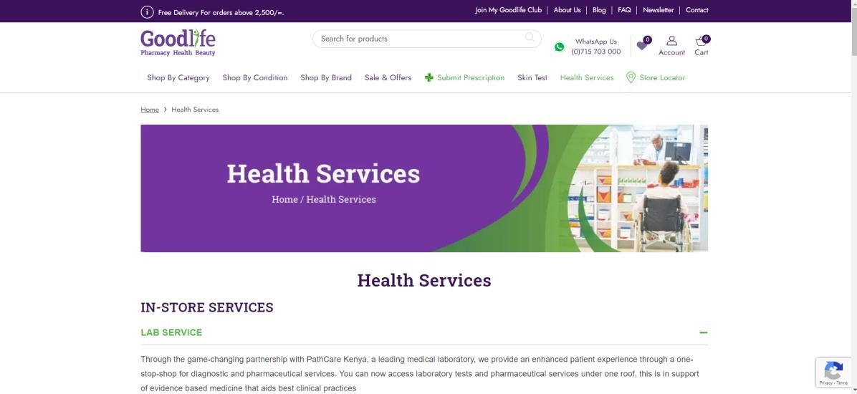

*Figure 2.2* A screenshot of some of the services offered by Goodlife Pharmacy

Goodlife Pharmacy is advantageous since it provides a reliable and efficient way of ordering medication. The medications are organised by category which narrows down the search making it easier for patients to find what they are looking for.



*Figure 2.3: A screenshot of the categories by which one can order.*

However, a major disadvantage is that the medications don’t come with a dosage or instructions on how to use them.



*Figure 2.4 A screenshot of a product and its details.*

## Portal Pharmacy

Portal Pharmacy is an online pharmacy application that accepts patients as users and allows them to order their medications.

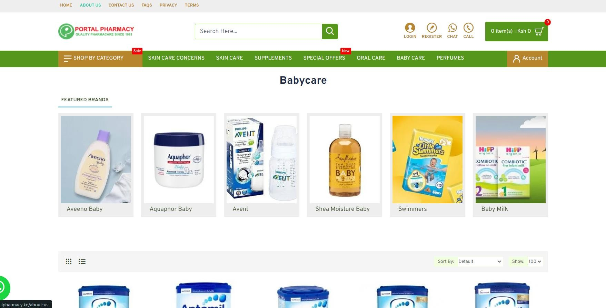

*Figure 2.5 A screenshot of the online pharmacy Portal Pharmacy.*

An advantage of this online pharmacy is that it allows users to order the drugs that they need and have them delivered to them, but a disadvantage is the user cannot access a healthcare professional online in the form of a consultation or any other way since the only service that is offered is medication ordering.

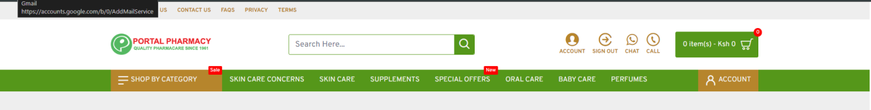

*Figure 2.6 A screenshot showing the services offered by Portal Pharmacy.*

## DawaSASA

DawaSASA Is an online Pharmacy that allows patients to order drugs and submit prescriptions. An advantage that dawaSASA has over other pharmacies is that one can also order medical equipment.

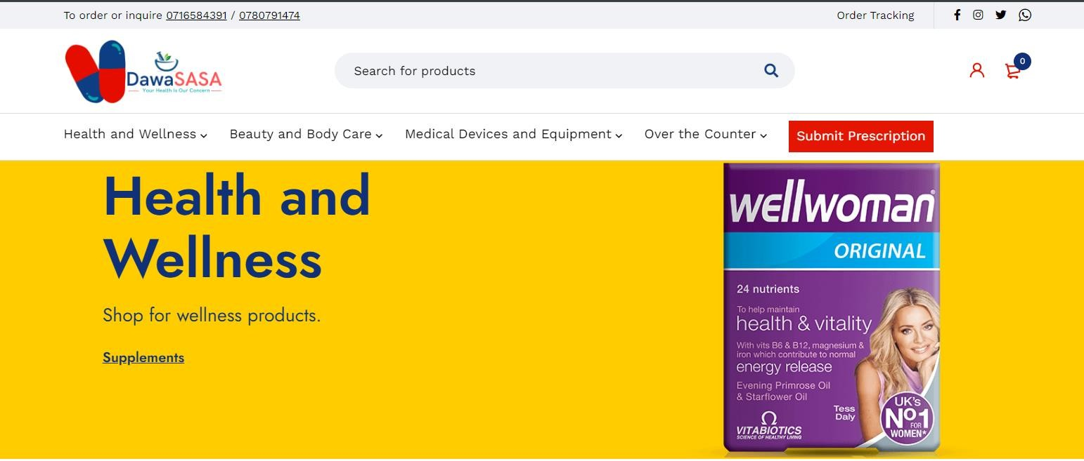

*Figure 2.7 A screenshot of the online pharmacy dawaSASA and the services offered.*

However, a disadvantage of dawaSASA is that they don’t have prescription medication available. That means that the medication that cannot be given without a prescription is not available at all.

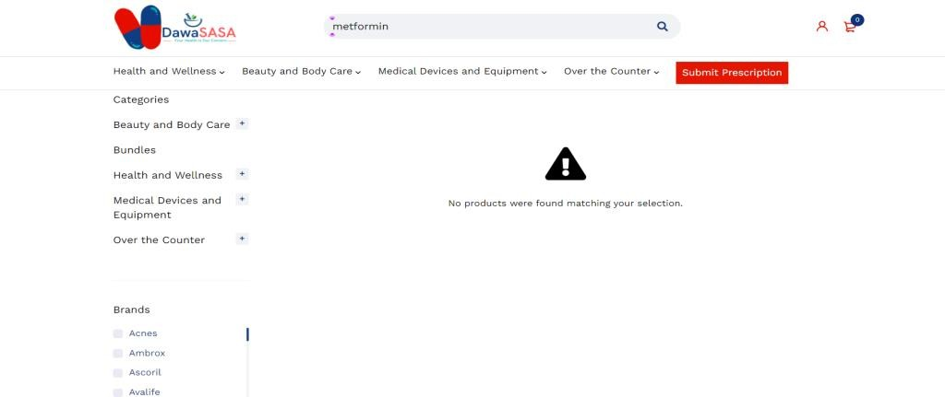

*Figure 2.8 A screenshot of the error that was encountered when trying to order a prescription medication.*

## Gaps in the Existing Applications

The main challenge that was experienced in GoodLife Pharmacy was that the Available drugs did not come with dosage instructions. In the proposed system, the drugs that are being ordered are going to come with dosage instructions for all ages and instructions on how to use them.

For Portal Pharmacy, the user interface was not friendly, and it wasn’t easy to register for the application. There also was no way for a patient to interact with a medical professional for a consultation or to make an inquiry. In the proposed system, patients should be able to interact online with a healthcare professional whether it is for inquiries or a consultation.

Additionally, in dawaSASA, there was no way of finding non-over-the-counter medication on the website. A user had to make a phone call to ascertain whether the medication is available. But in the proposed system, one should be able to search for and find the medication, but they cannot order it unless there is a valid prescription available.

## Conceptual Framework

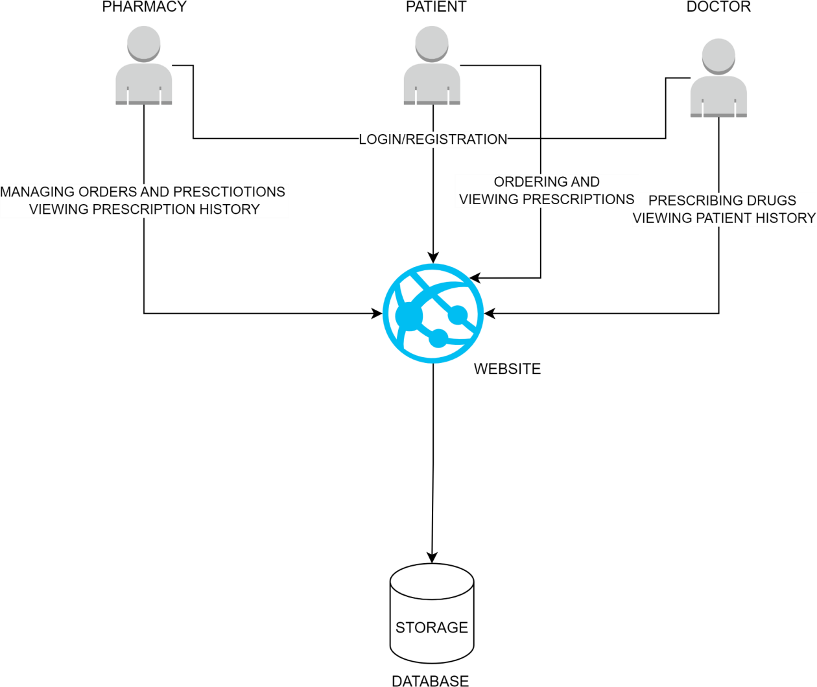

*Figure 2.9 Conceptual Diagram*

The conceptual framework above shows how the different users (Patients, Doctors and pharmacies) interact with the system in their individual roles.

# Chapter Three: Development Methodology

## Introduction

This chapter discusses the software development methodology Object Oriented Analysis and Design and the different aspects of the system analysis and design. Additionally, this section will highlight the tools and techniques that will be used in the application development and the expected system deliverables that will be presented at the end of the application development.

## Software Development Methodology

A software development methodology is an integrated set of practices, principles, and processes for the development of software systems. (IEEE Computer Society, 2014). The development methodology that will be used in the proposed system is the Agile methodology known as Scrum.

## Justification of the Methodology

One of the reasons why agile methodology is the most suitable methodology for the project is that it is flexible and adapts to constantly changing requirements. It also focuses on delivering working bits of the application in sprints; this is very advantageous since the project is organised into modules which are dependent on each other. Moreover, the methodology is user-centred (which is the focus of the application) since it is required by the customer that the development team provides regular deliverables to indicate the progress of the application. Additionally, the output that is produced is of high quality since testing is done throughout development. Lastly, it is easier to measure the progress by the amount of completed work **(**Kate Brush, 2022)

**Methodology Diagram**

The diagram below illustrates the overview of the Scrum Agile methodology:

(SCRUM INSTITUTE, 2011)

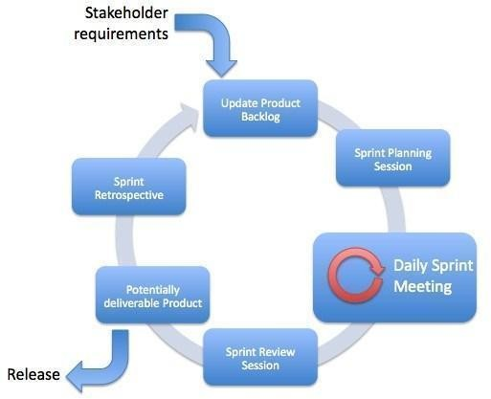

*Figure 2.10: A diagram representing the Agile Methodology*

## Update Product Backlog/ Product Backlog Creation

When it’s the first cycle of the process, the product owner comes up with a list of features for what they would like in the system called a product backlog and it serves as the single source of requirements for the development team. The product backlog is ordered according to priority. The process is known as product backlog creation. In the proposed system, the first step that will be taken is coming up with a list of possible features that need to be in the system and the list will be arranged in order of most to least important.

Updating the product backlog is done after an iteration is complete where the requirements need to be re-evaluated either because new information is available, or the requirements have evolved, and the priorities have changed.

## Sprint Planning

A sprint is a fixed duration in which a part of a system is developed, tested and released. During sprint planning, the top features from the product backlog are assigned to the development team members for the features to be developed in the upcoming sprint. In the proposed system, since the features will be organised in order of priority, the development order will be according to the list of requirements. i.e. the first feature on the list would be the first to be developed and tested.

## Daily Sprint Meeting

These are the daily meetings for brief discussions on the progress and to address any challenges that have been encountered. As partners, we intend to do updates on our progress every two days.

## Sprint Review Session

A sprint review is an event that is held at the end of each sprint where the team presents the increment of product that was developed during the sprint. At the end of each sprint, we review the completed work and feedback received to validate the functionalities of the application.

## Potentially Deliverable Product

This is the place where the product that was developed in the current sprint is released.

## Sprint Retrospective

Following the sprint review, a sprint retrospective meeting is held to reflect on the sprint process and areas of improvement are identified. After completion of the sprint, we will hold a session to review our performance and asses our areas of improvement.

After the sprint is completed, we begin a new sprint by updating the product backlog.

## Software Requirements Analysis

Software requirements analysis is the process of gathering, documenting, analysing, and validating requirements for a software system. (Sommerville, 2015).

## Functional Requirements

These are statements of services the system should provide, how the system should react to inputs, and how the system should behave in particular situations. In some cases, the functional requirements may also explicitly state what the system should not do. (Sommerville, 2015)

In this section, we will define the functional requirements for the web-based application for Drug Dispensing. These requirements will outline the key features and functionalities that the platform must support to ensure there is a patient-centred approach to the process of drug dispensing.

Firstly, there is user authentication, the system should require the users to authenticate themselves before accessing the dispensing tool to ensure data security and privacy.

Secondly, User profile management; the users should be able to create and update their personal information and their medical histories.

Some of the functionalities that are associated with the patients are: Patients should be able to conveniently order their medications online through the platform, the system should provide detailed dosage information and instructions on medication usage to patients and patients should have access to view their prescriptions within the platform for easy reference and medication adherence.

Other functionalities associated with the doctors are, that doctors should have an interface for managing patients and prescribing medications and the system should support electronic prescribing, allowing doctors to efficiently oversee treatment regimens and make informed prescribing decisions.

For pharmacies, it is expected that the module should be able to receive and process orders placed by patients and facilitate the management of prescriptions received from doctors to oversee treatments and make informed prescribing decisions.

Lastly, the system should be designed with accessibility features and user-friendly interfaces to accommodate users with varying levels of technical expertise and abilities.

## Non-functional Requirements

Non-functional requirements are constraints on the services or functions offered by the system. (Sommerville, 2015).

One of the constraints includes timing constraints: the system is set to adhere to the following deadlines, the proposal document is due on the 6th of May and the Final complete project is due on the 8th of July.

An additional constraint is the constraint on the development process. Since in the agile methodology, the requirements are constantly evolving, there is a lack of predictability in terms of the schedule of development.

## System Narrative

A system narrative is a detailed description of the functionality, behaviour, and interactions of a software system from a user's perspective. (Laganière, 2005)

The proposed system is about creating a web-based application for drug dispensing that is mainly centred around patients and their needs. It allows patients to order drugs from the website and they can view their prescriptions. It also includes doctors who attend to the patients by giving prescriptions according to their needs and pharmacists who dispense the ordered or prescribed drugs with the correct instructions on how to use them.

## System Design

System design is the process of defining the architecture, components, modules, interfaces, and data for a software system to meet specified requirements. It involves translating the requirements gathered during the analysis phase into a detailed blueprint or plan for constructing the system.

## Use Case Diagram

A use case diagram is a diagrammatic representation of the interactions between actors (the users) and the system under consideration; it provides a high-level view of the system’s functionality from the perspective of its users.

## Class Diagram

Class diagrams are visual representations of class objects in a modal system. It improves the overall quality of the software development process, and it promotes code reusability. The class diagram was used to provide a clear overview of the classes, their attributes, and the methods in totality.

## Entity Relationship Diagram

Entity-Relationship Diagram is a visual representation of the entities in a database and the relationships between them. It's a modelling technique used in database design to illustrate the structure of a database system.

## Database Schema

A database schema is a structural representation of the logical and physical layout of a database. It defines the organisation, structure, and integrity constraints of the stored data. In essence, it outlines how data is organised and how different elements within the database relate to each other.

The following is the database schema for the proposed system and the diagram that shows the output after running the SQL.

## System Development Tools and Techniques

## Database Management System (DBMS)

In our proposed system, MySQL is chosen as the database management system (DBMS) due to its user-friendliness and extensive features. MySQL is an open-source relational database management system widely used for web applications and other data-driven projects. Its popularity stems from its ease of use, reliability, scalability, and extensive community support.

## Integrated Development Environment (IDE): Visual Studio Code

This is the open-source code editor developed by Microsoft which will be important in the development of the proposed solution as it will provide an environment for programming and application development tasks. It is the best for use in our project as it has all the necessary tools and plugins needed for use.

## version Control System: GitHub

This is an internet hosting service for software development and version control using Git. It is important in this study because it enables easy collaboration during the development of the proposed solution which will allow us to track our work and make changes dynamically which is needed since our approach is Agile.

## Programming Languages

Since it is a web-based application, we will be using HTML, CSS, and JavaScript (React.JS or Node Js)

## Documentation Tool: Microsoft Word

We decided on Microsoft Word as a documentation tool since it enables the creation and sharing of the project's documentation. It will be used to document the requirements and other essential chapters in the proposed project.

## Agile Development: Scrum Technique

In the proposed system we are going to be using the agile development technique Scrum since it emphasises on iterative development and tasks are developed incrementally. It also factors in the constantly changing requirements and there is room for flexibility in the development process.

## Deliverables

The expected deliverables include:

## The System Proposal Documentation

This is the document that outlines the objectives, scope, methodology, timeline, resources required, and expected outcomes of the proposed project. It serves as a detailed plan which will be followed in conducting the research. Its purpose is to communicate the importance and workability of the project to prove the value of the developed solution.

## Authentication Module

This is where the users of the system (Patients, Doctors, and the Pharmacy) can create an account to register for the service or log in to their existing accounts in the system. The module should be able to identify the type of user and redirect them to their relevant user interface so that they can access the service they need.

## Administrators Module

This module will be accessible to the administrators. They should be able to access the lists of the users of the system and oversee the users of the system. They can add users to the application and suspend accounts.

## Patients’ Module

The patient’s module will be developed to allow the patients to order their medication, view prescriptions if they have any from the doctors and make inquiries.

## Doctors Module

In the doctor's module, the doctor should be able to view the patient's history and the list of previously prescribed medications and symptoms. They should also be able to search for patient records, edit and add to them. They should also be able to prescribe drugs to the patients.

## Pharmacy Module

In the pharmacy module, the pharmacies should be able to manage the orders that are made by the patients and dispense the drugs ordered appropriately. Additionally, the pharmacy should manage prescriptions from the doctors by dispensing the drugs listed in the prescription to the patients. The pharmacy should also have access to the patient’s prescription history so that they can make more

informed decisions when accepting orders. Lastly, the pharmacy should manage the drugs available by either adding new drugs to the system or removing drugs that are no longer available.

# References

Abuga K, O. D. (2019). Sub-standard pharmaceutical services in private healthcare facilities serving low-income settlements in Nairobi County, Kenya. *Pharmacy*, 167.

Aywak D, J. C. (2017). Pharmacy practice in Kenya. *Canadian Journal of Hospital Pharmacy (Can J Hosp Pharm)*, 465-462.

Cerqueira-Santos. (2022). Which factors may influence the implementation of drug dispensing in community pharmacies? *Journal of Evaluation in Clinical Practice*, 83-93.

Gabay, M. (2015). Regulation of internet pharmacies: a continuing challenge. *Hospital Pharmacy (Hosp Pharm).*, 681.

Godman B, M. M. (2018). Dispensing of antimicrobials in Kenya: a cross-sectional pilot study and its implications. *Journal of Research in Pharmacy Practice (J Res Pharm Pract)*, 77.

IEEE Computer Society. (2014). *Guide to the Software Engineering Body of Knowledge (SWEBOK.* Hoboken, NJ: John Wiley & Sons, Inc.

JavaTpoint. (n.d.). *Software Engineering - Agile model*. Retrieved from JavaTpoint: https://[www.javatpoint.com/software-engineering-agile-model](http://www.javatpoint.com/software-engineering-agile-model)

Kate Brush, V. S. (2022, November). *Agile Software Development.* Retrieved from TechTarget. Laganière, T. C. (2005). *Object-Oriented Software Engineering: Practical Software Development*

*Using UML and Java.* McGraw-Hill Education.

lindayane Vieira de Souza, L. J.-S. (2022). Evaluation of pharmacist’s practices regarding the antimicrobials dispensing. *BMC Health Services Research*.

maloba, v., & Brandy, A. (3546). gfgafg. *ttjhhm*, 36-45.

Orizio G, M. A. (2011). Quality of online pharmacies and websites selling prescription drugs: a systematic review. *Journal of Medical Internet Research (J Med Internet Res)*, Article e1795.

Pharmacy and Poisons Board. (2019). *Pharmacy and Poisons Board*. Retrieved from Google Scholar.

Pizetta, B. (2021). Does drug dispensing improve the health outcomes of patients attending community pharmacies? *BMC Health Services Research*, 764.

R. J. Cipolle, L. M. (2012). *Pharmaceutical Care Practice: The Clinician's Guide.* McGraw-Hill Medical.

Royal Media Services . (2021, May 20). *World Pharmacists Day*. Retrieved from Citizen Tv Kenya: <http://www.youtube.com/watch?v=98KSyfcdefM>

SCRUM INSTITUTE. (2011). *Scrum Example: A Real-Word Scrum Example for Top Agile Teams*. Retrieved from SCRUM INSTITUTE: https://www.scrum- institute.org/Introduction_to_Scrum_A_Real_World_Example.php

Siyoi, F. (2021, August 22). *Avoid self-medication*. Retrieved from Pharmacy and Poisons Board: https://[www.pharmacyboardkenya.org/blog/2017/12/avoid-self](http://www.pharmacyboardkenya.org/blog/2017/12/avoid-self)–medication.

Sommerville, I. (2015). *Software Engineering.* Pearson Education Limited is the publisher of the book.

Vida RG, M. S. (2020). Developing a framework regarding a complex risk-based methodology in the evaluation of hazards associated with medicinal products sourced via the internet. *Saudi Pharmaceutical Journal*, 1733.

Wafula F, M. C. (2013). Wafula F, Molyneux C, Mackintosh Maureen, et a. *Social Science & Medicine (Soc Sci Med*, 220–227.

Wambulwa, A. (2021, May 13). *Pharmacy outfit wants unqualified technicians barred*. Retrieved from The Star: https://[www.the-star.co.ke/news/2019-04-04-pharmacy-outfit-wants-](http://www.the-star.co.ke/news/2019-04-04-pharmacy-outfit-wants-) unqualified-technicians-barred/

Wanyanga WO, V. S. (2020). *Pharmaceutical partnerships for increased access to quality essential medicines in the East Africa region.* Retrieved from The Scinnovent Center: https://idl-bnc- idrc.dspacedirect.org/bitstream/handle/10625/59578/59713.pdf?sequence=1&isAllowed= y.

World Health Organization. (2021). *The World Health Organization. Monitoring the building blocks of health systems: a handbook of indicators and their measurement strategies.* Geneva: WHO.

# Appendix

## Inserting image...Appendix1 Time schedule

*Figure 11: Time Schedule*